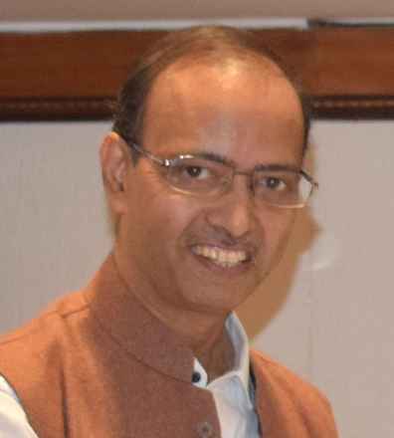
Brief Bio-sketch
of
Prof. Chandan Ghosh, Ph.D(IIT-K), Dr.Engg. (Ibaraki Univ, Japan)
Department of Civil Engineering, Indian Institute of Technology, Jammu
Professor of Civil Engineering
Jagti, NH-44, Nagrota, J&K, India 181 221
http://disasterresilientindia.blogspot.in/
https://www.facebook.com/chandan.ghosh.9887117
https://twitter.com/cghosh24
Email: chandan.ghosh@iitjammu.ac.in

Chandan Ghosh, a Civil Engg. Graduate (1985) of Bengal Engineering College (presently Indian Inst. of Engg. Sc. & Technology, IIEST), West Bengal, did his Master’s degree in Civil (Geotechnical) Engineering (1987) from Jadavpur University, Calcutta, followed by Ph.D. from IIT-Kanpur in 1992 and Dr.Engg. in 2004 from the Ibaraki University, Japan.
After serving IT-BHU (1990-1998, currently IIT-BHU),Varanasi, Post Doctoral research in Japan (1998-2004), India Meteorological Department (2005-2006) and 13+plus years as Professor & Head (2006-2019), Disaster Resilient Infrastructure Division, National Institute of Disaster Management, Ministry of Home Affairs, Govt. of India, Dr Ghosh is currently working as Professor of Civil Engineering, IIT-Jammu (on Deputation).
Prof. Ghosh works in the areas of earthquake geotechnology, Reinforced Earth, Seismic Microzonation, HYBRID drains for ground improvement, Auditing and Rapid Visual Screening of built-up facilities, Geosynthetics for landslides mitigation and Bio-engineering applications by Vetiver Grass for sustainable developments.
He has devoted more than 30 years of his career in UG & PG teaching, research administration & guidance, development of teaching tools & training module for engineers, architects, town planners.
He has guided/mentored several master’s and PhD dissertations, visited/documented several post-disaster sites, taught PG courses in IIT Delhi/Dhanbad as visiting faculty, conducted 100+ professional capacity building programs in Disaster Resilient Infrastructure/Management, gave more than 250 invited/keynote/memorial lectures and published more than 125 papers in reputed journals, conference proceedings, book chapters.
As recognition to his seminal contributions, Dr Ghosh, currently member of State Disaster Management Authority, Tripura, received Leonard prize for the best doctoral thesis in 1993, CIDC-Vishwakarma Awards-2013, IGS-Shri H.C. Verma Golden Jubilee Award-2013, Lifetime achievement award-2019 (Indian Geotechnical Society-Delhi Chapter).

